Conserve Energy
Unplug what’s not currently being used
DON’T!! DO!!
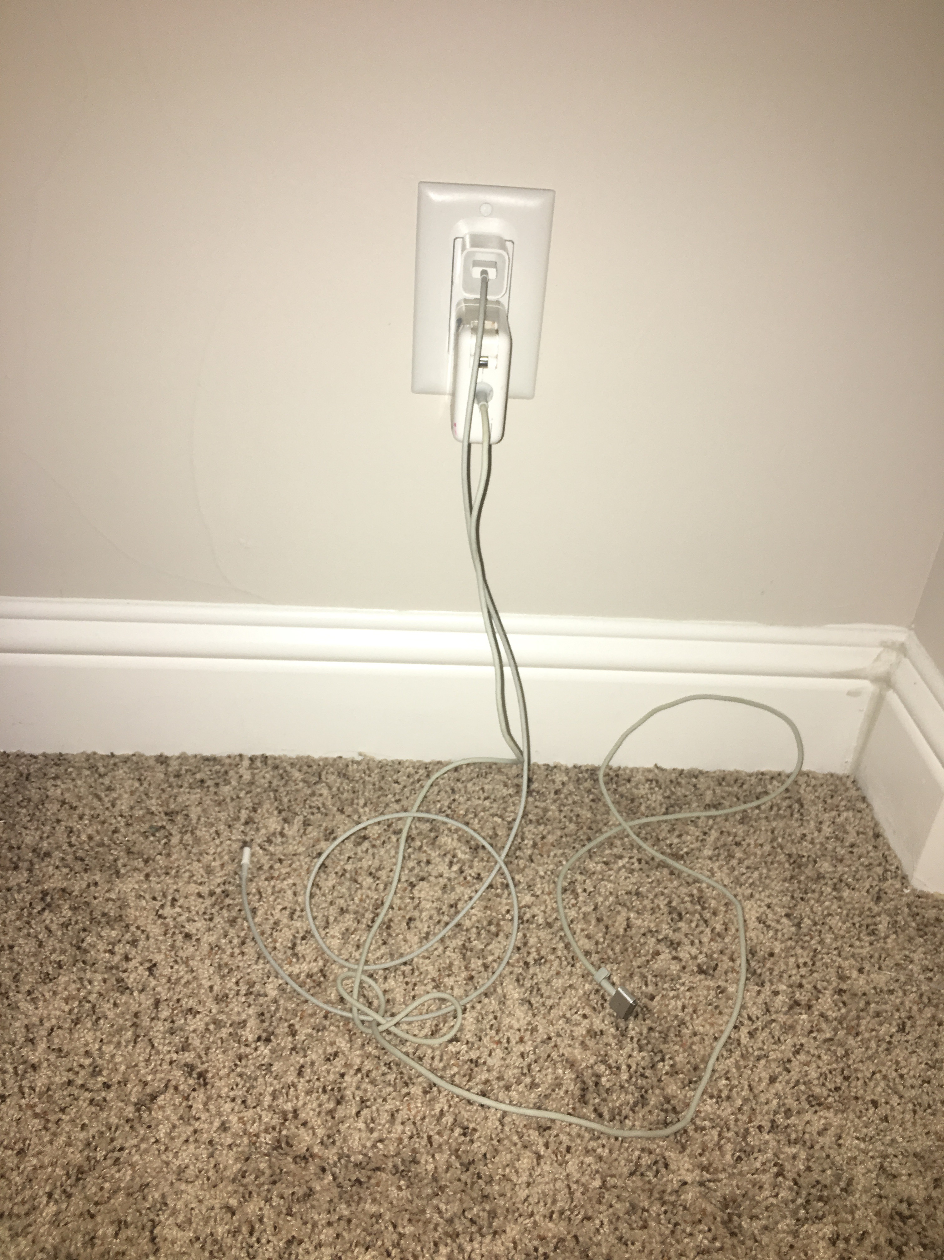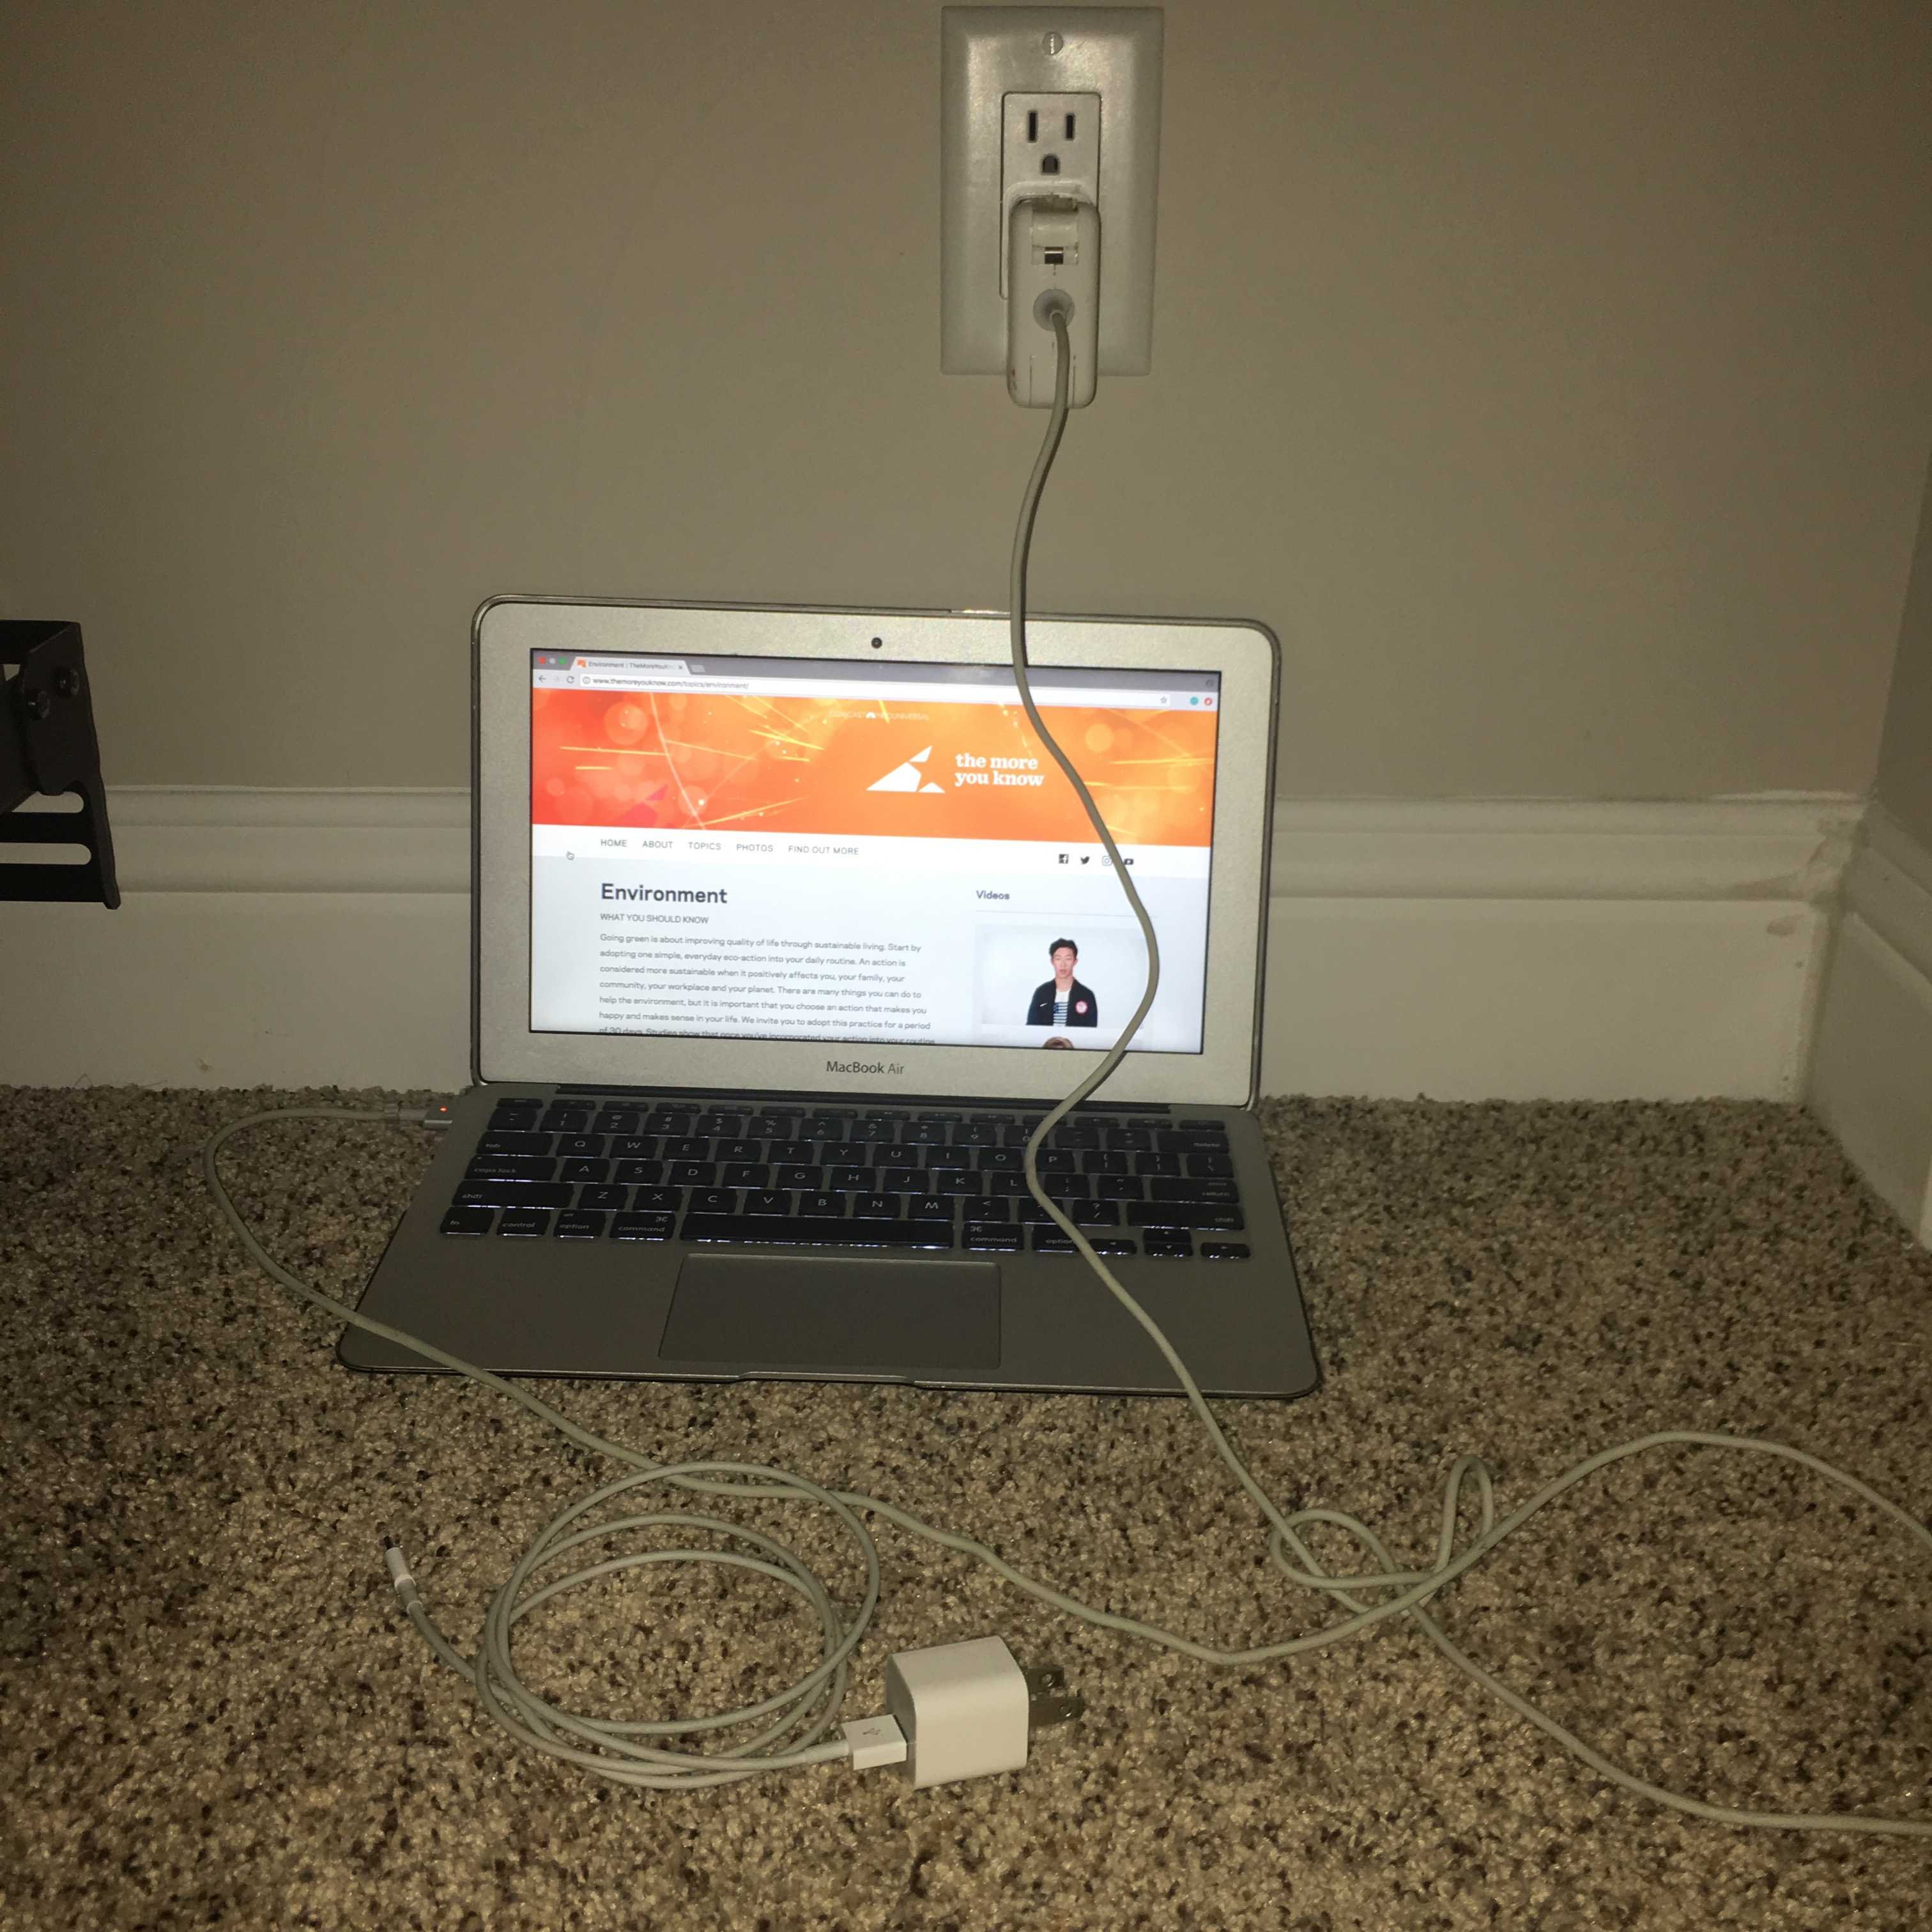
Power in your house usually comes from power plants. Power plants are fueled by burning coal or other fossil fuels. So everytime you leave a light on or a charger plugged in when they aren’t needed, you’re polluting the air.

