Consume Plants

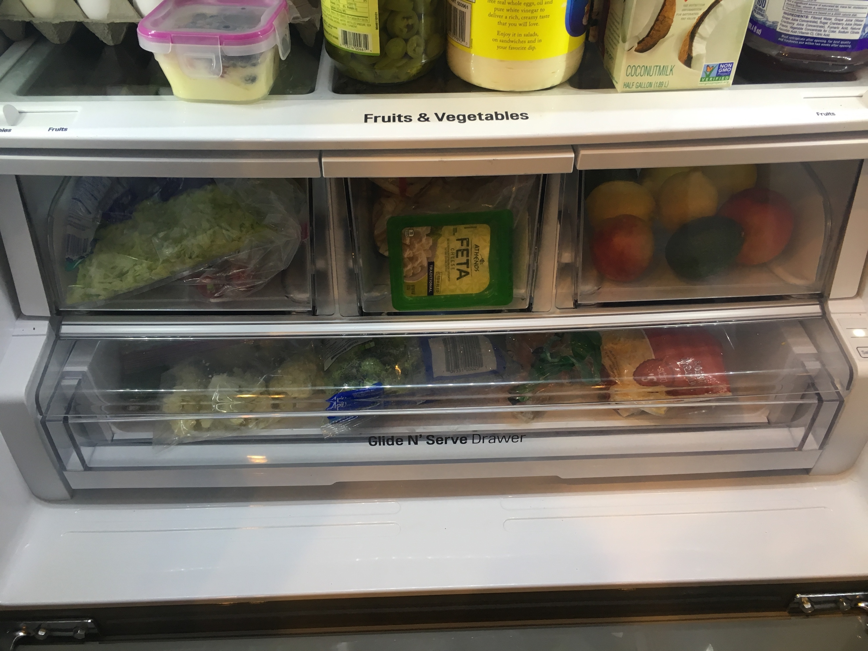

Don’t worry I don’t mean all plants. I’m talking about fruits and vegetables, which is something you should eat more of than meat. As we know, meat comes from animals. There are many species going extinct lately, so let’s prevent extinction. The more meat we eat, the more closer those animals become extinct, and we could be next after them.

