Only use dishwasher when full

DO NOT! DO!!
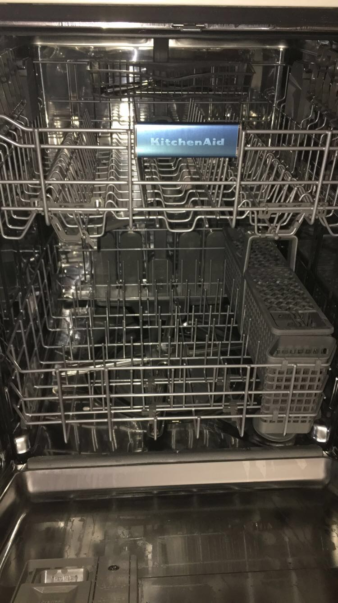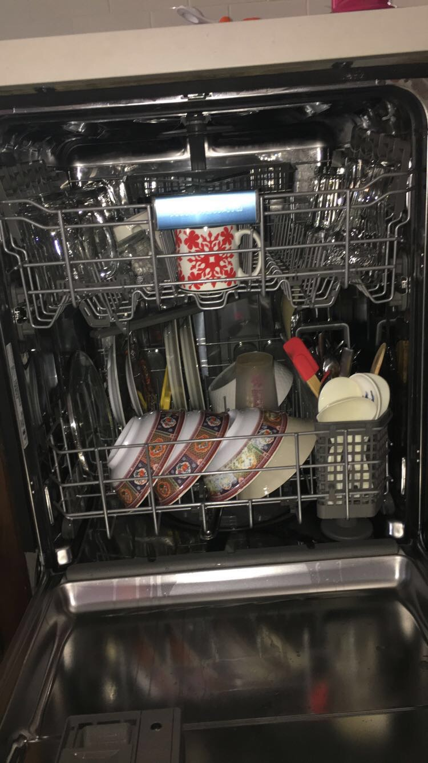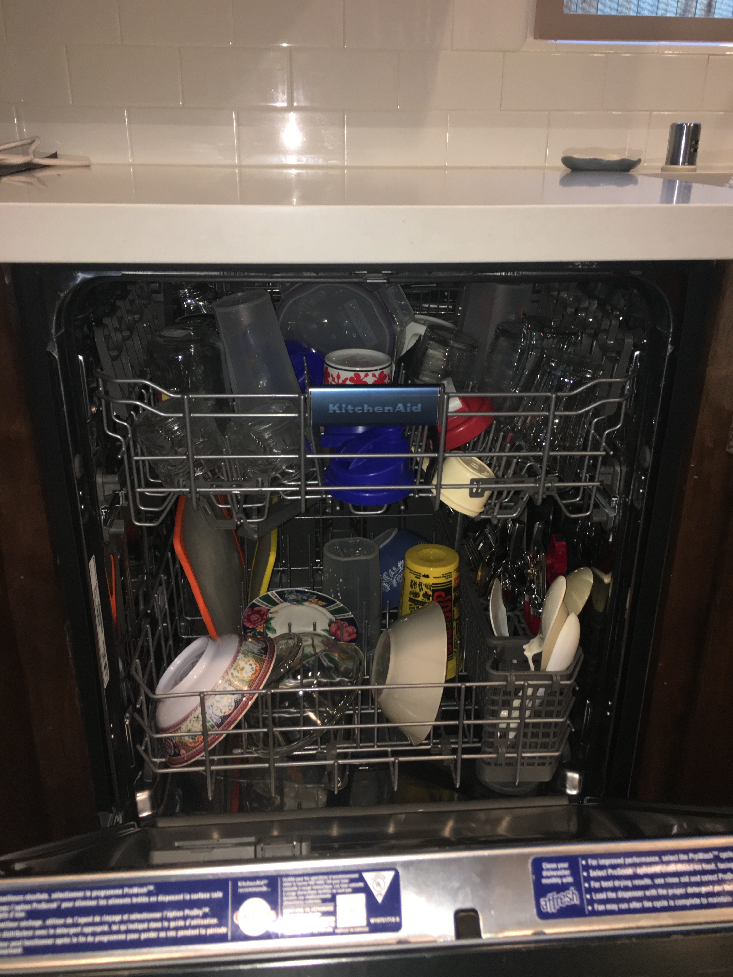
Why? You would be wasting water. Be aware that there are a lot of places in droughts, and yours could be too.
Suggestion: hand wash the dishes (but turn the water off when soaping them before rinsing) and then let them dry in the dishwasher.

